TEST new network code.

**#1** Per discussion with Chen, for the networks we may want to have a function to download the graph data in a format that can be used by other tools. That is download the edge and node information into a format that can be imported by other tools (e.g. what formats does gephi use?, gephi.org)

**#2** MAC Issue: Problem when pressing Start button for Network Analysis. Failed on .DS_Store, I think the software tried to read it as a directory –

Error: ENOTDIR: not a directory, scandir '/Users/jmtroy2/Documents/TEST_GRAPHQL/analytics-standalone/downloads/GraphQL/.DS_Store'  
    at Error (native)  
    at Object.fs.readdirSync (fs.js:952:18)  
    at readDIR (/Users/jmtroy2/Documents/TEST_GRAPHQL/analytics-standalone/scripts/helper.js:8:25)  
    at /Users/jmtroy2/Documents/TEST_GRAPHQL/analytics-standalone/routes/networkx/networkx.js:12:14  
    at Layer.handle [as handle_request] (/Users/jmtroy2/Documents/TEST_GRAPHQL/analytics-standalone/node_modules/express/lib/router/layer.js:95:5)  
    at next (/Users/jmtroy2/Documents/TEST_GRAPHQL/analytics-standalone/node_modules/express/lib/router/route.js:137:13)  
    at Route.dispatch (/Users/jmtroy2/Documents/TEST_GRAPHQL/analytics-standalone/node_modules/express/lib/router/route.js:112:3)  
    at Layer.handle [as handle_request] (/Users/jmtroy2/Documents/TEST_GRAPHQL/analytics-standalone/node_modules/express/lib/router/layer.js:95:5)  
    at /Users/jmtroy2/Documents/TEST_GRAPHQL/analytics-standalone/node_modules/express/lib/router/index.js:281:22  
    at Function.process_params (/Users/jmtroy2/Documents/TEST_GRAPHQL/analytics-standalone/node_modules/express/lib/router/index.js:335:12)

/Users/jmtroy2/Documents/TEST_GRAPHQL/analytics-standalone/downloads/GraphQL/.DS_Store

**NOTE: this is a MAC problem, so when we test on hubzero it should not happen.**



**#3 Interactive Network Visualization (D3JS) – very nice!! Makes things easier to test.**

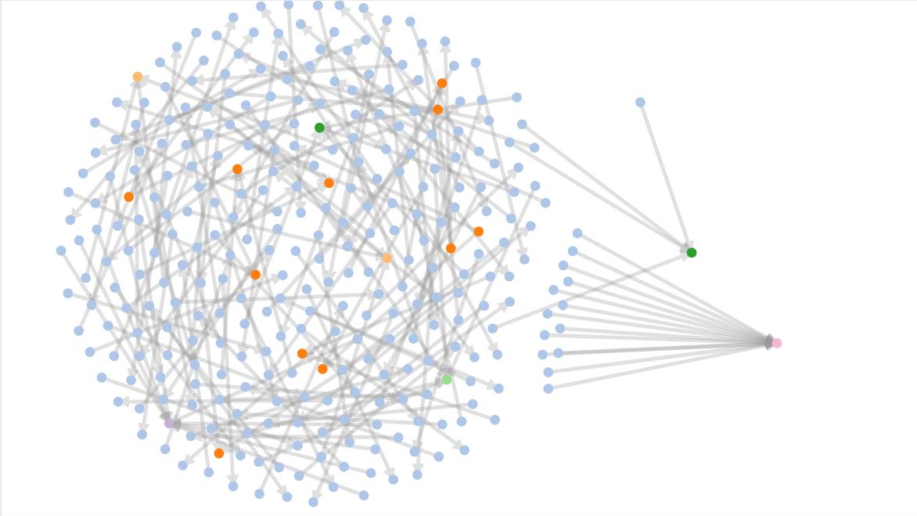

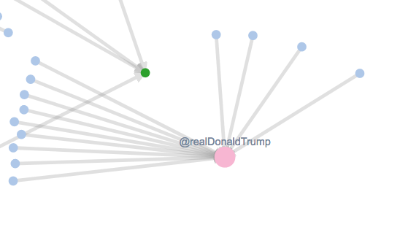

#4 Colorscale



Maybe add a few more words to tell users the colorscale relates to the degree of the nodes (how many edges it has)

#5 Network Analysis retweets

When looking at the data where “**retweet from**” was selected as the network relation, it looks like the tweets are “replies to” or “mentions”, and not “retweets”



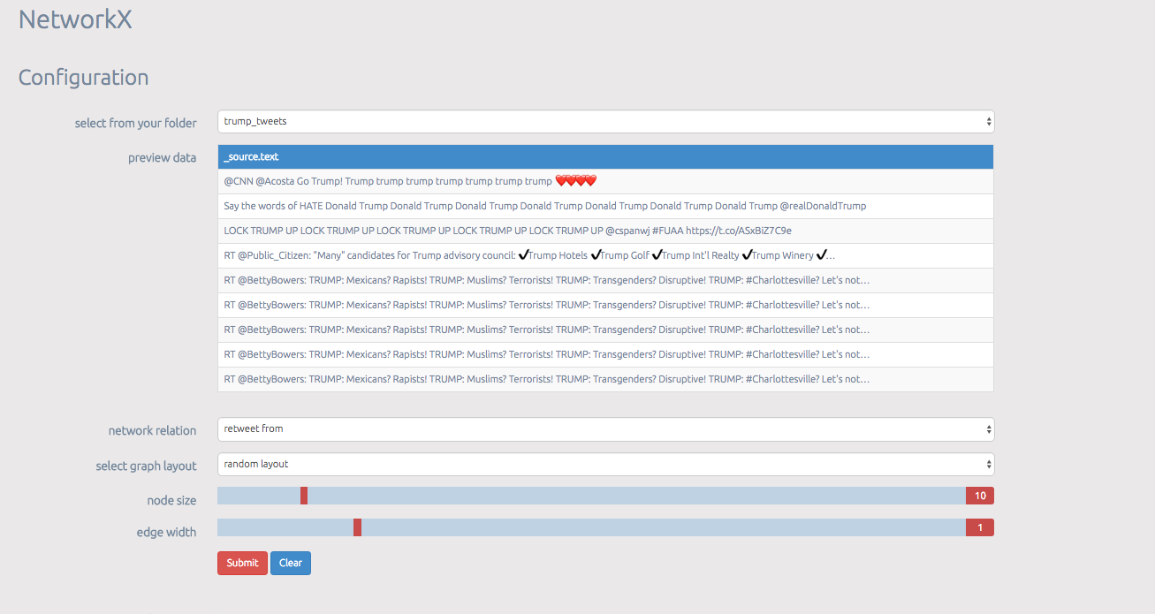

**#5a**

When I reviewed my data file, **20 users replied** to @realDonaldTrump. So I think the 20 is just in the wrong place.

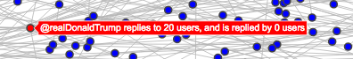

***The D3JS looks good*** (below), In my screen print you can not see the arrow heads pointing to trump, but they are there

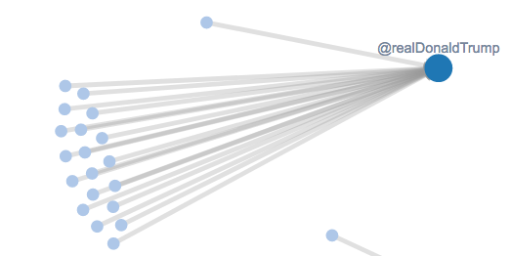

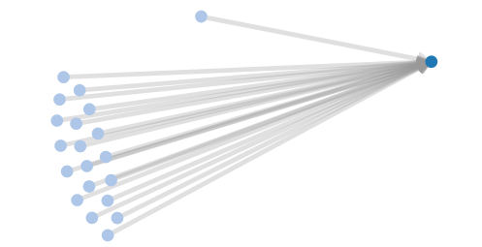

**#5a continued.**

Also, waynestuartrc replies to 1 user, and was replied to by 0, Maybe just the wording is causing confusion.



**#5b –** Chen, this may be an issue with an “_” in the screen name. The D3JC visualization only shows 6 replies to FoxNews, but there are seven per the “trump5” data, and also in the centrality metrics file (centrality.json). The screen name missing in the D3JS visualization is Llan_Llanos.

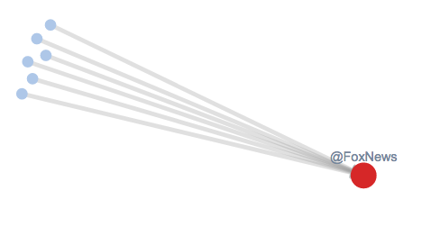

**#6** Suggestion – I test the node size and edge width on Network Analysis and it works file, but maybe change labels to: node size (networkx), edge width (networkx), and Static Network Visualization (networkx). Just to help understand the difference between the parts that are plot.ly and D3JS.

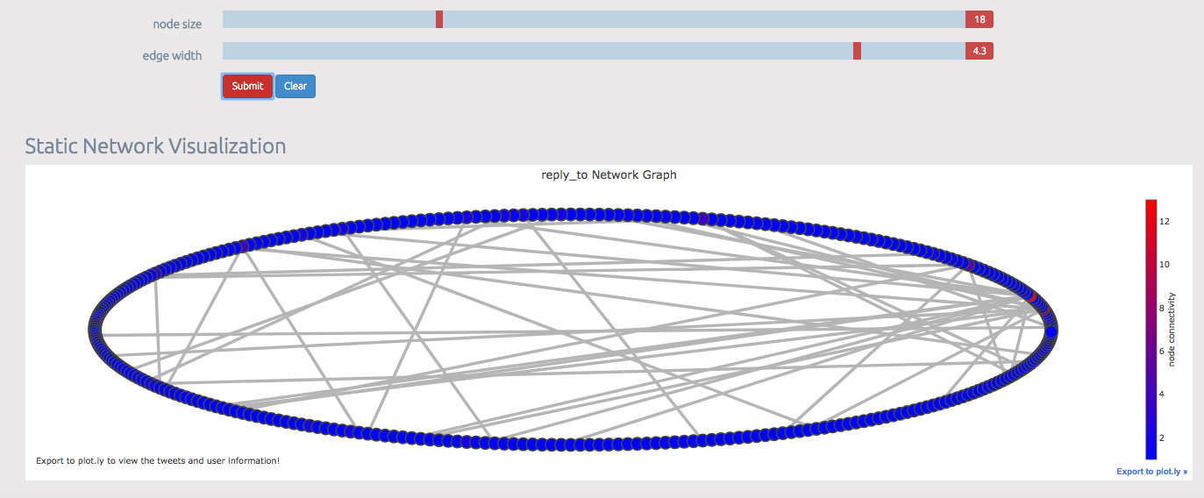

**#7** filename illegal error message.

This happens when I press the “advanced” button, but do not put any text in the “Tweet keywords that you wish to search…” box.

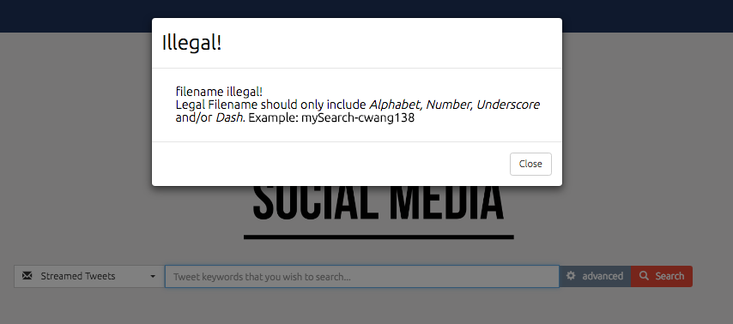

**Test file management**

Just an FYI: if opening a .csv file of saved tweets in Excel, the tweet id may lose precision in the rightmost 3 digits. The .csv file is fine, ***this is an excel issue***. Work around may be to import file into excel instead of just doing an open.

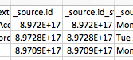

test VIEW button:

TEST 1 – looks good

